Lighting your fire pit - thecountrylife

1. Step 1 – Tinder
First, we will create a little ball of tinder in the centre of the fire pit. It only needs to be about the size of your palm.
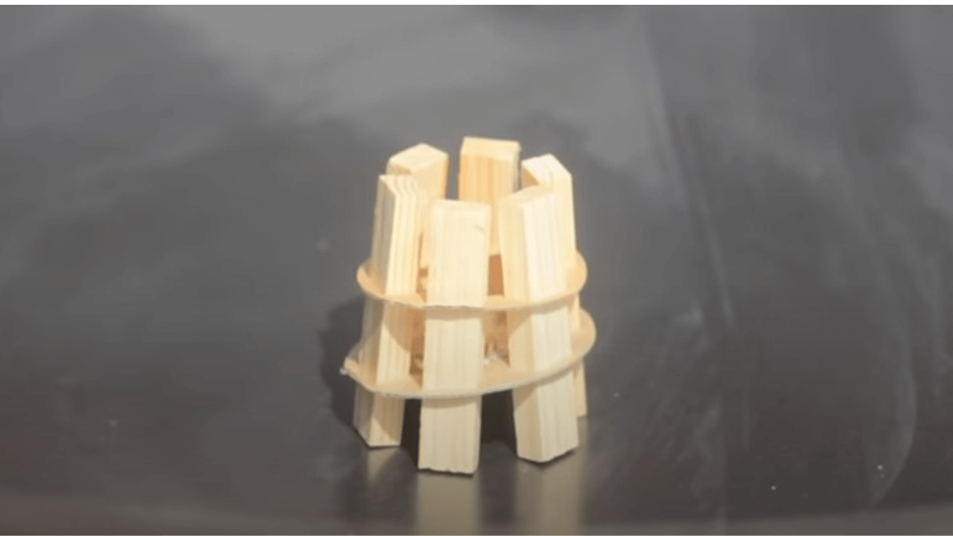

2. Step 2 – Kindling
Next, we will build a little pyramid of kindling sticks around the ball of tinder. It’s important to leave a bit of a gap to let air flow, but not too much so that the flames from the tinder don’t reach the kindling.
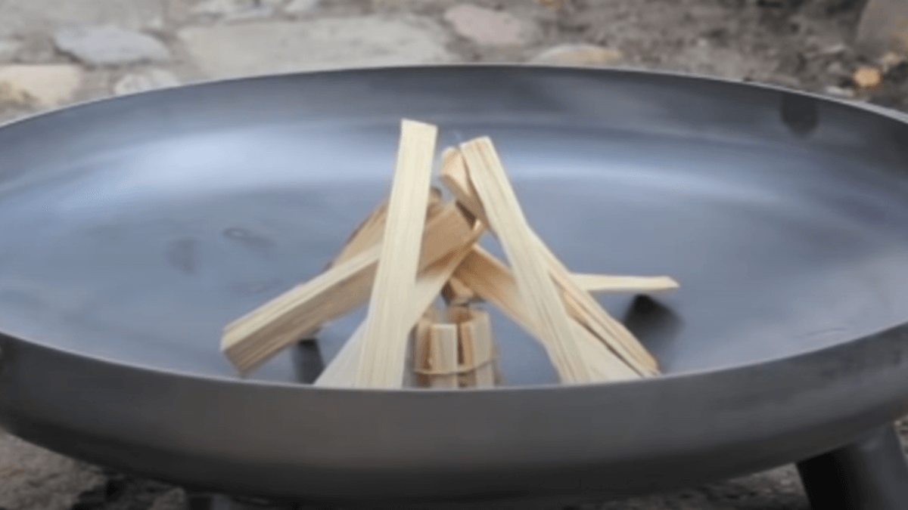

3. Step 3 – Lighting
Now we light the tinder. Pull out your firelighter and burn the tinder until it catches fire. Your aim here is for the tinder to set light to the kindling. If your tinder is burning up too quickly, and the kindling has yet caught light, just add more tinder.
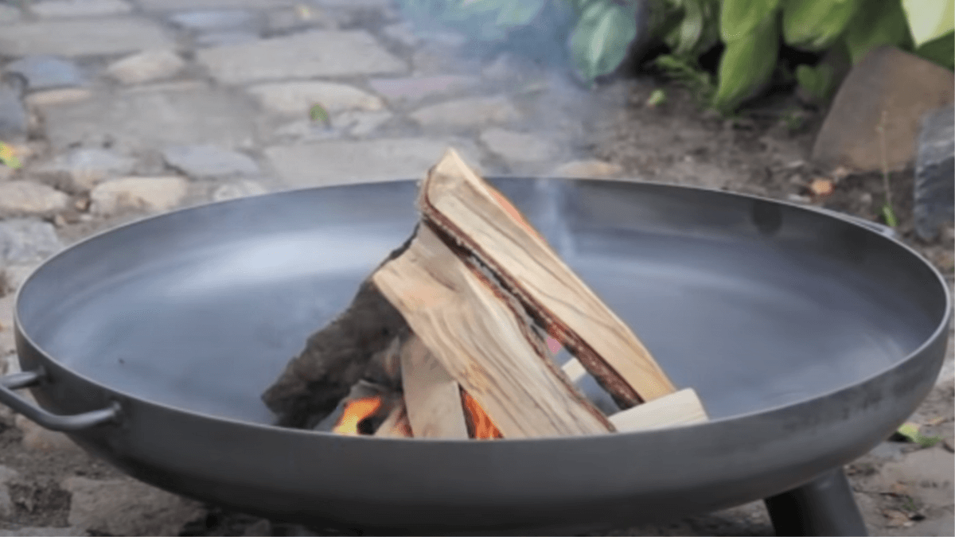

4. Step 4 - Firewood
Once your kindling is burning it's time to add your firewood. Again, we are going to arrange the logs in a pyramid around the kindling, making sure to leave enough of a gap for airflow.
If the firewood is taking a while to light, then you can always add more kindling underneath to keep the heat up

